**Big Data Analytics and Applications**

**LAB-1 TASK-1**

**By**

**Group-3**

**N. Ayyappa Kumar,**

**G. Vishnu Praveen,**

**P. Siva Kumar,**

**V. Akhilesh.**

**Task 1:** Apps with Mobile Devices and Sensors

**Subtask1:** T1 sensortag with Android sensor app.

For this task we require minimum android version of 4.3. Open android SDK create new project then copy the sample project in to it.

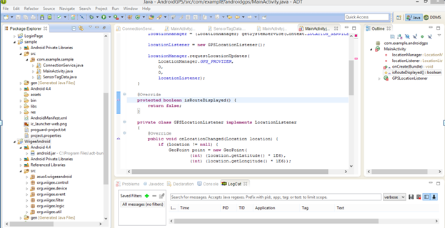

*before launching the app turn on your sensor tag.

*Now install and connect the app on your android phone. Your DDMS should detect your phone.

After installing the app you can see the output screen as follows.

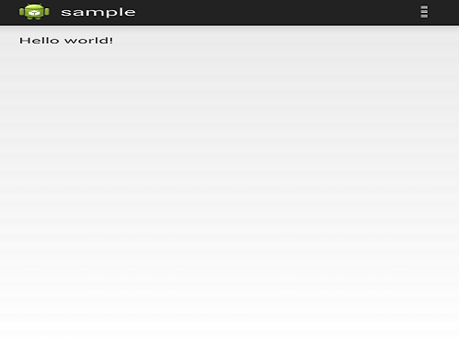

* When ever you get an change in data from the sensor, updateAccelerometerCals() in connection service picks up and logs the details.

* There is a log statement in the Connection Service, which prints the x value of the accelerometer data. You can see the result in your logCat.

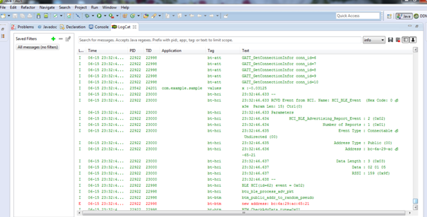

Different values of ‘x’ can be observed in the log cat as follows.

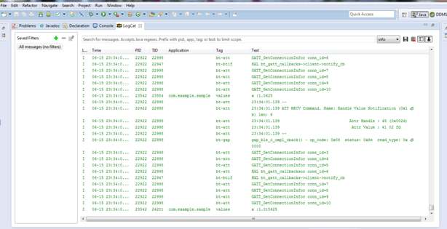

**Subtask2: Mobile Sensor with Android Sensor App:**

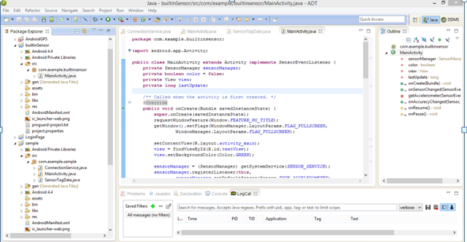

The app name is “builtinSensor”. The color of screen will switch between green and red as you shake your mobile device.

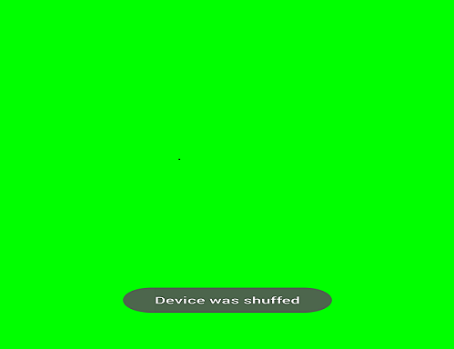

If we move the screen the color changes from green to red as shown below.

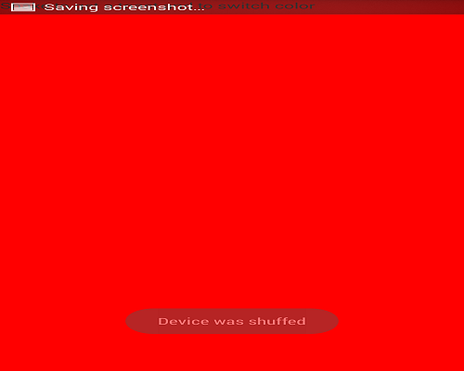

**Subtask3: GPS feature with Android smart phone**

* We design an app to get the current location by Android GPS feature

* We have to use Google API to run the app

* We have to turn on your GPS location as “on” in phone settings

*After the app installations you can see the Android GPS as he folder structure in your eclipse.

*You can see the latitude and longitude of the current location using the GPS application.

*It shows the screen in the mobile as below.

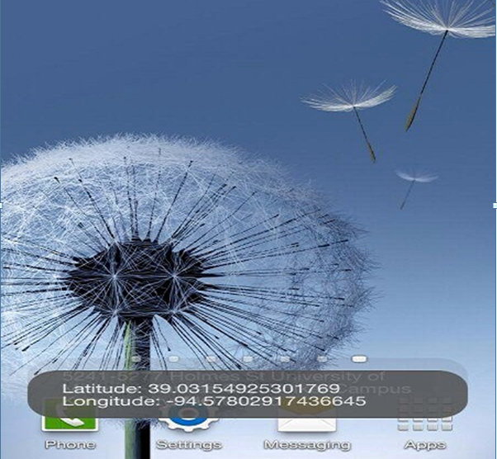

**Subtask4: Wiigee app with Android smart phone**

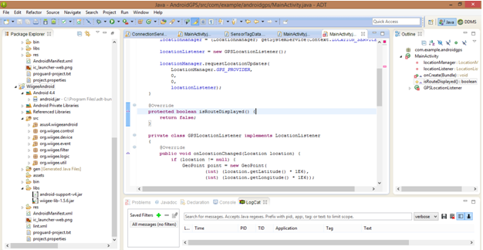

Connect and install app on your android phone.

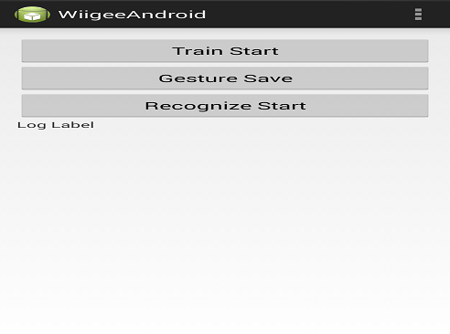

The main page of the app is as follows.

It has 3 tabs

1. When we click on Train start the motion gets started in.
2. Later we save the gesture by clicking on second button.
3. Later it should recognize the motion.

The step by step continues as follows.

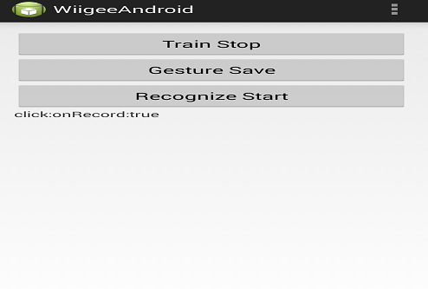

When we click on the train start it shows as the above screen as a recording is continuing.

Record=true.

After that when we tap on the stop record it shows as record= false.

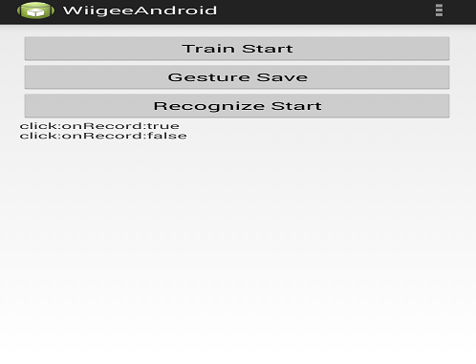

After taping the gesture save button , it says click on save then it will be saved.

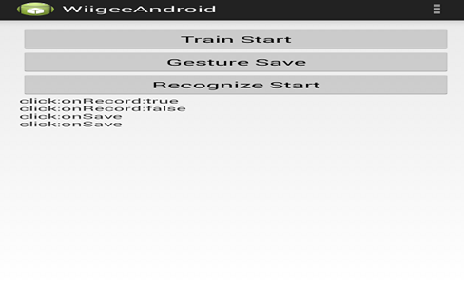

Later it prompts to click on recognize

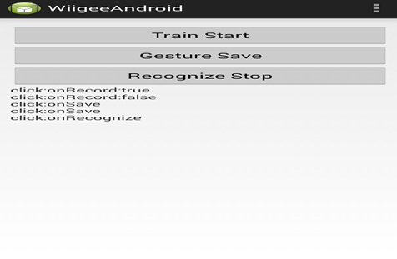

After clicking on the recognize button it then displays as follows if there is motion detected and shows the probability of the motion recognition.

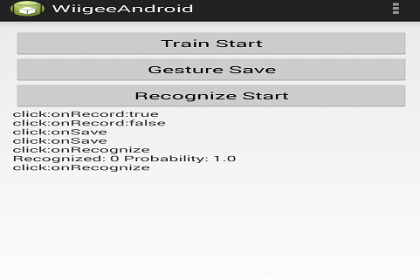

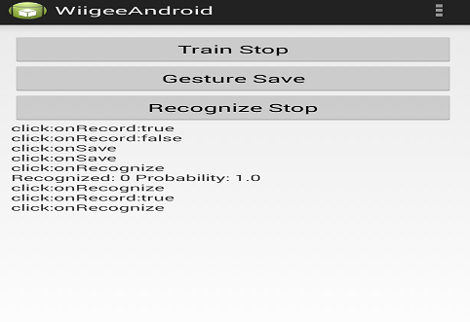

Various recognitions can be done as shown below.

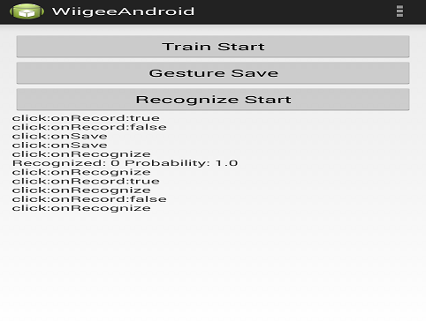

**Subtask5: T1 chronos with JAVA app**

* To connect chronos watch to your pc, you have to plug a USB connector to your pc and click the broadcasting button on the watch to broadcast the sensor signal.

* To test your chronos watch, you have to install the control center from CD

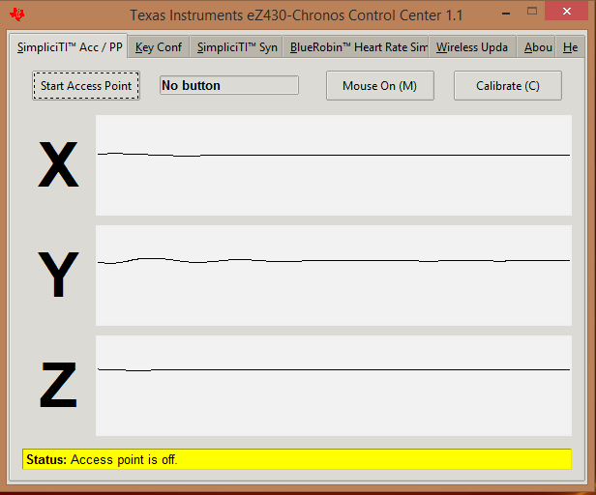

Click start access point to start testing. Later it asks for watch to turn on.

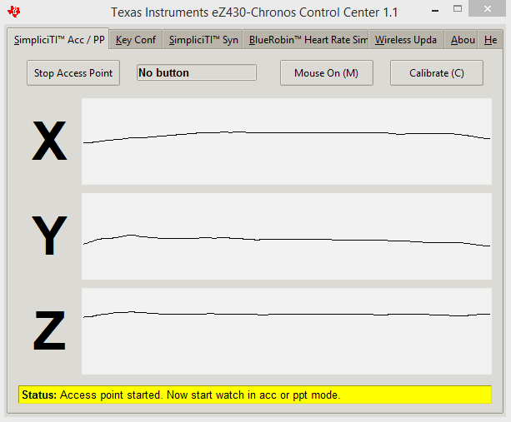

Note that you have to change your watch mode to either ACC or PPT to test

ACC to test x, y, z movement and PPT to test button click

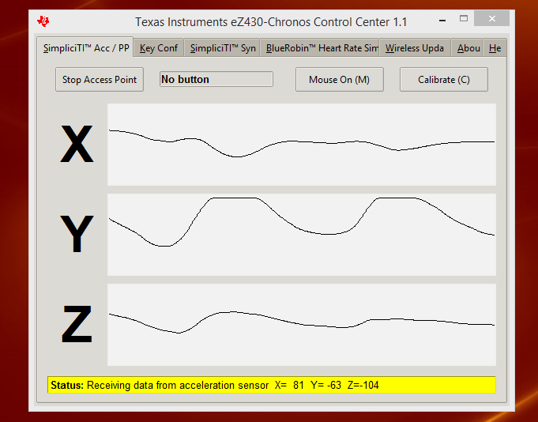

Later data is received and values of all the parameters are shown as below.

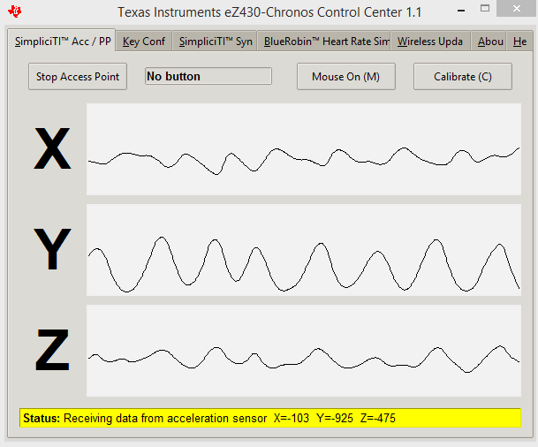

**Punch meter Game:**

* Download the game from:

<http://processors.wiki.ti.com/index.php/File:PunchMeterGameExes.zip>

* Run the exe file and open the game

The screen appears as follows after the game installation

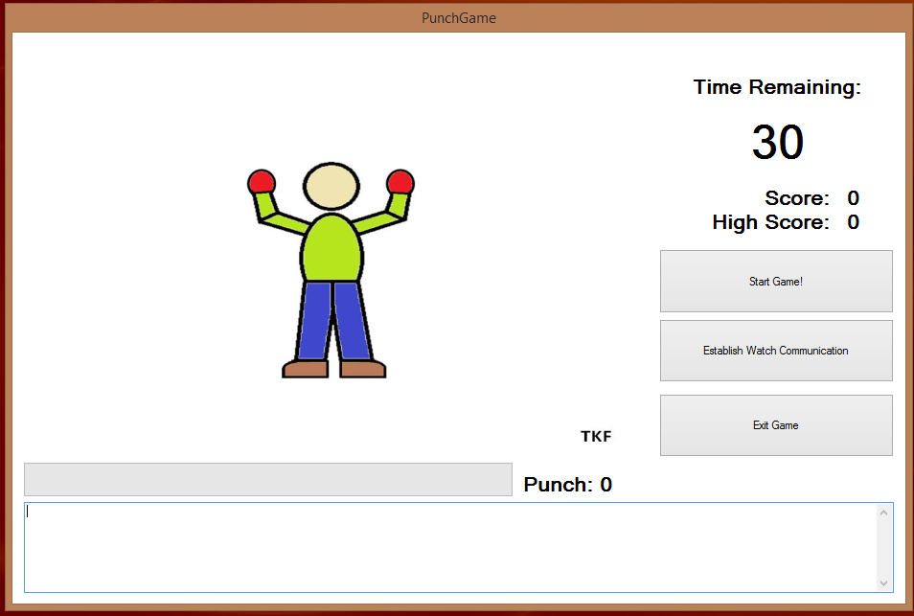

* Before play, you have to click “Establish Watch Communications” to make watch connected to your pc.

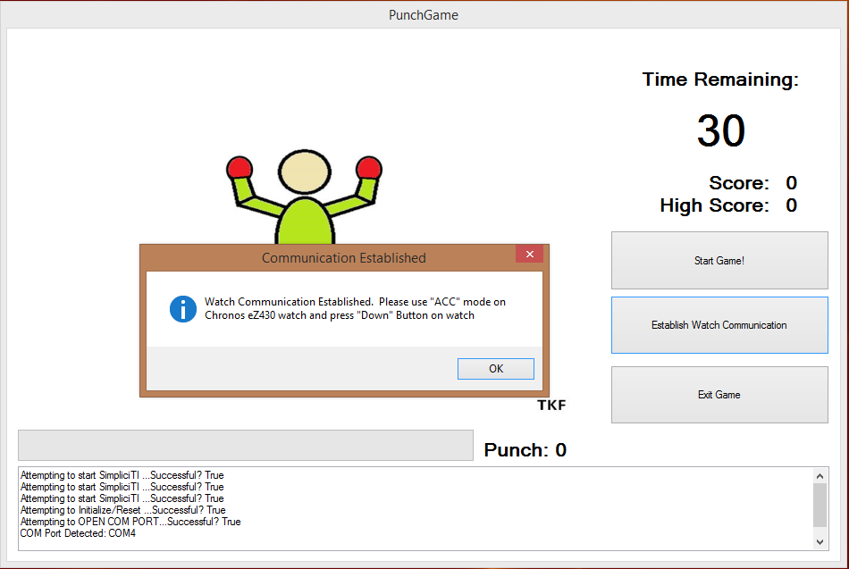

After the connection of the watch,

* Then click start game to start

* You have to start the watch broadcasting also

It displays the score and the remaining time in seconds as follows.

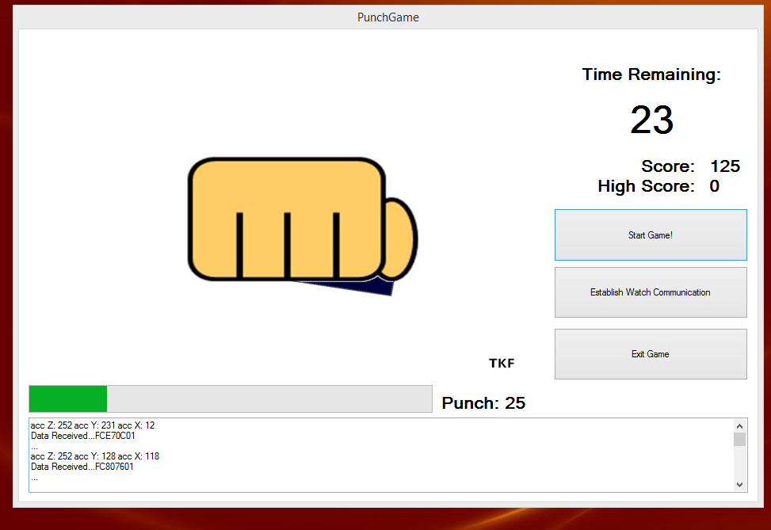

After completion of the game it shows the highest score and the pop-up appears as if the game is completed.

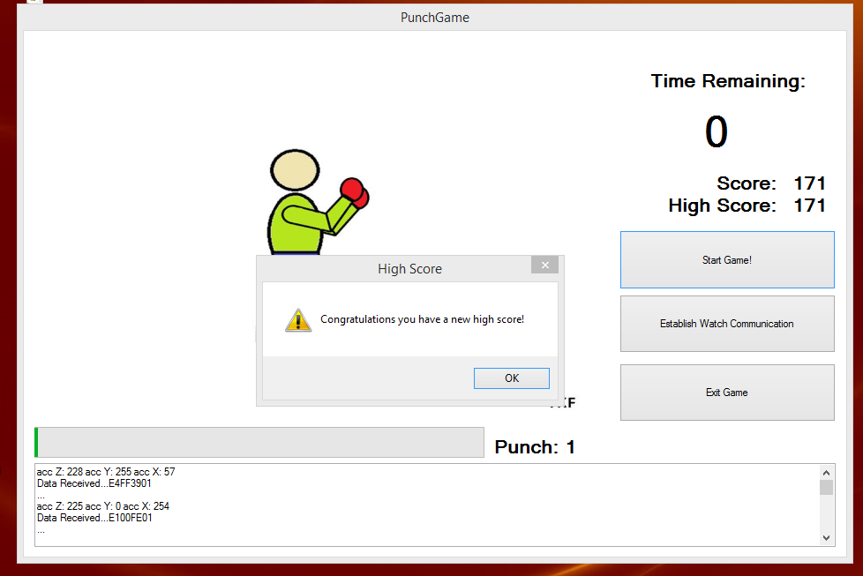

Similarly we can play or start the game once again.

